General Accessibility Guidelines for CCS
(February 2022)

Alt Text
What Is Alt-Text?
Alt-text, or "alternative text, is the text that a screen reader will read out loud when an image, graphic or table is encountered on a webpage. Alt-text might also be referred to as an "alt tag," "alt attribute" or image description.
Why we use Alt-Text
Alt-text allows screen readers to read information about images out loud to users who are blind or and visually impaired. alt-text is necessary so that people who are visually impaired can still access the information provided by an image, and understand its purpose and why it’s present. It’s also important as alt-text is what will display in place of an image that fails to load.

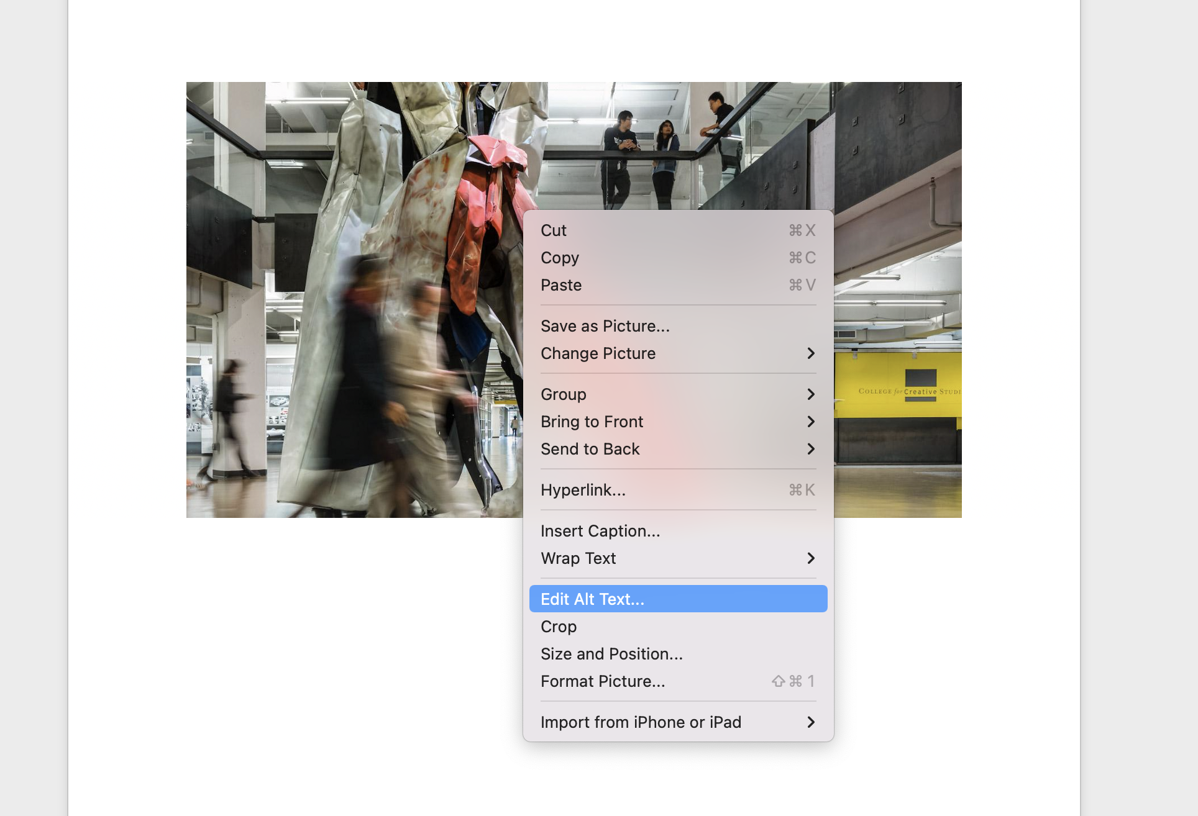
*An example of how to edit alt-text in Microsoft Word

General Guidelines for Alt Text
- Keep it precise. The alt-text should describe the content in the image accurately and to the best of your ability.
- Stick with relevant information. You don't need to describe every single detail, just those that matter in terms of how the image is being used in context and what information the reader needs to know. A helpful method is to imagine you can’t see the image—what description would you need to hear to accurately describe the image without being overly wordy?
- Avoid using "image of" at the beginning of the description. A screen reader will announce its reading alt-text for an image before it begins reading it, so this will only duplicate that announcement.
- If an image is simply decorative (ie. no value/information relevant to the page—like a decorative page border), then the alt-text can just be described with the word "null" or "decorative."
- If you have infographics or images of text (like charts and tables), the alt-text should state all of the information provided, including every word that appears on the image. Another solution to this would be to provide a text-only version of the infographic.
Additional Resources
https://webaim.org/techniques/alttext/
https://www.w3.org/WAI/tutorials/images/decision-tree/

Closed Captioning

What is closed captioning?
Closed captions are a text version of the audio content of a video. This includes spoken words, but also information about who is speaking and any sounds relevant to understanding context and meaning. For example: [laughter], [applause], [footsteps], etc.

Closed captions should be synchronized with the audio. They appear on the screen as the video plays so that the information being presented in the video is the same information being conveyed by the text in the closed captioning.
Why Add Closed Captions?​
Adding captions to your videos is essential for helping those who are deaf or hard of hearing. Captions can also be helpful to those who aren't hearing-impaired as well (ie. people may be speaking with an accent that may be harder for some to understand easily; captions help those viewers follow along).
How do I add Closed Captioning to my videos?
You can add closed captions to your own videos by uploading them to YouTube. YouTube can automatically create closed captions for you, however, you will still have to manually watch/check the captions and correct them as needed to make sure they accurately capture the audio content. While it’s a free service, it’s not always 100% correct in picking up different accents/dialects, so it’s important to double check before publishing your video.

Audio Transcripts

What are Audio Transcripts?
Ann audio transcript is a text version of audio content. This includes spoken words, as well as information about who is speaking and any sounds relevant to understanding context and meaning. Unlike closed captioning, audio transcripts are separate files that users can refer to without simultaneously playing the audio—similar to a movie script.
Why Add Audio Transcripts?
We create audio transcripts so those with hearing impairments can still access the information. Transcripts can also benefit all users since they create a searchable version of audio content and can provide clarity on what’s being said if there is a misunderstanding.
How do I create an Audio Transcript?
You can either create audio transcripts yourself by listening and typing, or use a service that will create them for you. For audio you've already created, you may be able to save some time by uploading your file to YouTube, which will generate captions for you, and then downloading them as an editable transcript. It is, however, important to note, that you will still need to double check these captions as YouTube’s closed captioning is not always 100% accurate.
General Tips for Audio Transcripts
- At the top of the page, include identifying information such as title, and date. For example: "BFA Programs at CCS" from The College for Creative Studies, created on Oct. 31, 2020.
- Always indicate who is speaking. Be sure to include their full name (if possible), and any other relevant information such as titles, class, years, etc. When they speak again, you can continue to identify them by their full name, or an abbreviated version (ie. ‘Daniel Smith’ the first time, and ‘Daniel’ for subsequent mentions)
- Describe any sounds relevant to understanding context/meaning. For example: [laughter], [applause], [footsteps], etc.
- Split text into short paragraphs to make it easier to read.

Tables

What are Tables?
Tables are a great way to organize data using rows and columns. While they’re easy for screen readers to read, they shouldn’t be used for convenience or as a design element; they should always have a purpose.

Making a Table Accessible

Include a Header Row
This row is used to state what kind of information is contained in each column. This provides context for the data and assists screen readers in navigating the table.
Like Headings, header rows require a little extra formatting to be meaningful to screen readers.To make a header row in Microsoft Word:
- Choose Insert > Table to insert a table.
- Choose the number of boxes you want across to create columns, and then choose the number of boxes you want down to create rows for your table.
- On the Design tab, choose the Table Styles Options group, and then choose Header row.

Name | Points Scored | Points Possible
Megan | 99 | 100
Kate | 99 | 100
*An example of a Table with a Header Row

Use a simple structure
Avoid nesting tables within tables, and merging or splitting cells. All of these will make it very difficult, if not impossible, for screen readers to read the information in a logical way that makes sense to the user.

Add Alt-Text to your Table
Depending on the size of the table, having a screen reader read through it can be both exhausting, and confusing for a listener. Using alt-text to add a short summary of the information provided in the table gives users the option of listening to a summary, or the entirety of the table.
This can be done in Microsoft Word by right-clicking on your table and selecting ‘Table Properties’
Avoid Blank Cells
You should never leave the left uppermost cell blank, as it's the first cell a screen reader user will encounter. Blank cells anywhere in the table could also mislead someone using a screen reader into thinking that there's nothing more in the table.
Don't Use Screenshots
A screen reader can't read an image, so a person using a screen reader won't know what data is contained in a screenshot of a table. Build your tables natively in the program you’re using.

Additional Resources
Create accessible tables in Microsoft Word: https://support.microsoft.com/en-us/office/video-create-accessible-tables-in-word-cb464015-59dc-46a0-ac01-6217c62210e5?ui=en-us&rs=en-us&ad=us

Headings

What are Headings?
Headings are a type of text formatting. You may already use bold, color and/or a larger font to distinguish the section titles in your content, but that type of formatting alone won't allow a screen reader to recognize the text as a heading. You also need to format the text using the heading styles (ie. H1, H2, H3, etc.).

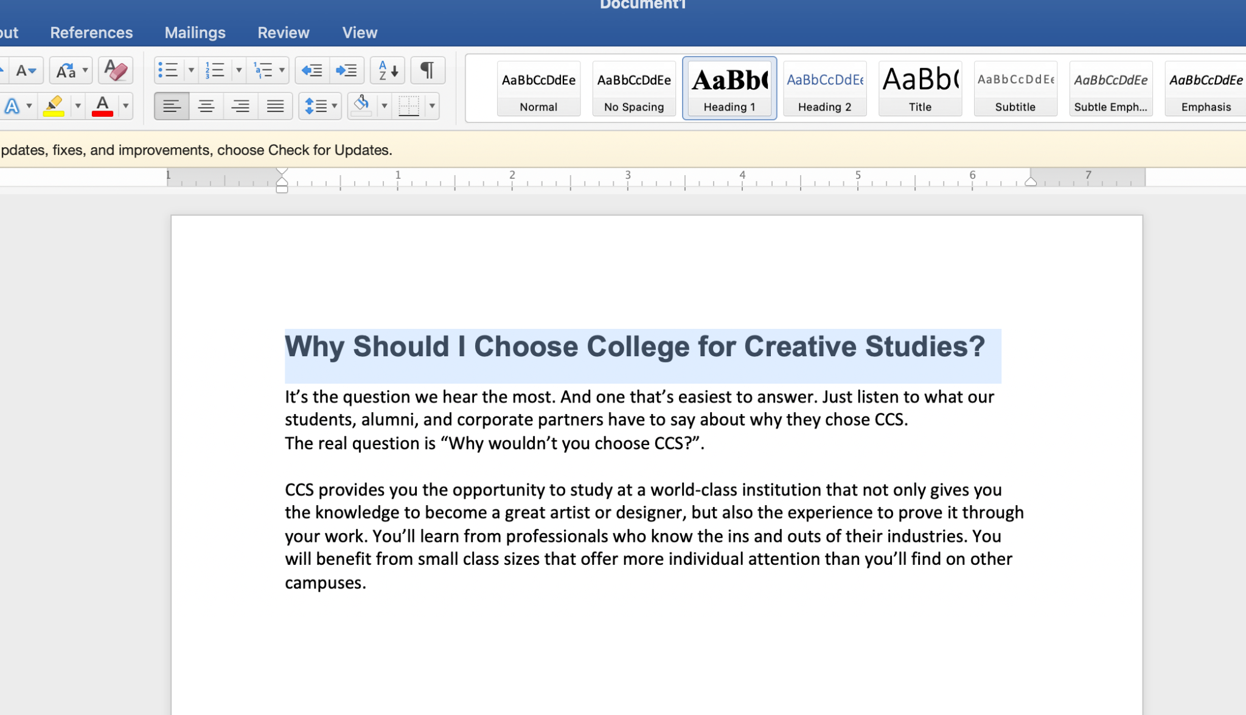

*An example of a heading style being applied in Microsoft Word.

Why Use Headings?
People using screen readers need to have text formatted in certain ways in order to easily navigate content, otherwise, the screen reader doesn’t know which order to read the content to the user. Heading structure allows screen reader users to easily search for sections and jump directly to specific content without having to listen to the entire document each time.
You should add headings to indicate all main topics and subtopics, especially in longer documents.
How do I create Headings?
Both Microsoft Word, and Google Docs all provide style and formatting options to help you build heading structure into your documents.
Creating headings in Microsoft Word: https://support.microsoft.com/en-us/office/add-a-heading-3eb8b917-56dc-4a17-891a-a026b2c790f2?ui=en-us&rs=en-us&ad=us
Creating headings in Google Docs: https://support.google.com/docs/answer/116338?hl=en&co=GENIE.Platform%3DAndroid

Heading Hierarchies
You should use headings in a hierarchical (nested) order to indicate main topics and subtopics.
- Your H1 is usually a page title or the main content heading. It's the most important heading, and there is generally just one Heading 1.
- Your H2 is usually a major section heading.
- Your H3 is usually a sub-section of a Heading 2, and so on (ending with H6)

Example of proper structure:
This is the title of my article (H1)
This is a section heading (H2)
This is a sub-section heading (H3)
This is a sub-section heading (H3)
This is a sub-section heading (H3)
This is a section heading (H2)
This is a section heading (H2)

Colors & Contrast

Contrast
C​ontrast is the difference between two colors. To make your content accessible, you need to have a high contrast ratio between your text and the background color. If your text is dark, your background should be light, and vice versa. Black text on a white background is recommended for paragraphs of text. We abide by WCAG 2.0 AA standards which means text must have a 4.5:1 contrast.
Colors can be used in moderation if there is enough contrast between the text and background, but you should avoid colored text on a colored background. When text and background color are too similar, it can be difficult for your audience to read the information being presented; especially for those with visual impairments such as color blindness.
Using Color in Text
When the importance of information is communicated using color alone, that importance is not conveyed to people who are blind or could be misunderstood by those who are colorblind. This is why it’s important to use other styling to signify important information other than simply color.
Styling text as bold or italic are examples of other ways to highlight information outside of color.
Using color as a Background
It can be eye-catching to use a bright and/or distinctively patterned background to add more visuals to a page or interface, however, these backgrounds can make pages difficult to read and can be painful to look at over long periods of time. In general, it's best to either avoid patterned backgrounds entirely or use very subtle patterns. This includes backgrounds on images, icons, buttons, etc.

Additional Resources
Contrast Checker: https://webaim.org/resources/contrastchecker/

Descriptive Links

What Are Descriptive Links?
Descriptive links are links that are worded in a way in which the user can know where they're jumping to without the context of where the link is listed.
Example of a URL link: ​​https://www.collegeforcreativestudies.edu/why-ccs/
Example of a generic link: Learn More
Example of a descriptive link: Why you should choose CCS

Why Add Descriptive Links?
It gives the reader a sense of context–You can tell right away what the link is, and what clicking it will do.
It makes it easier to skim the page for content—In a page full of "click here'​s," you need to read everything to find out which "here" you need to click. Meaningful descriptions make it easy to find the right link, right away, and provide better context for screen readers.
Improves the accessibility of your website—Providing descriptive text is important for screen reader users, who often navigate websites by going from link to link. Providing descriptive links allows those users to discern which link goes to what content.

General Resources for Accessibility
https://www.w3.org/WAI/standards-guidelines/#wcag
https://webaim.org/

Color Contrast Checker: https://webaim.org/resources/contrastchecker/
Web page Accessibility Checker: https://wave.webaim.org/

